Ex. No. 8 Simulation of a DFA URK19CS1063
AIM
To simulate the concept of deterministic finite automaton.
DESCRIPTION
In theory of computation, a branch of theoretical computer science, a deterministic finite automaton (DFA)—also known as deterministic finite state machine—is a finite state machine that accepts/rejects finite strings of symbols and only produces a unique computation (or run) of the automaton for each input string.
A deterministic finite automaton M is a 5-tuple, (Q, Σ, δ, q₀, F), consisting of
- a finite set of states (Q)
- a finite set of input symbols called the alphabet (Σ)
- a transition function (δ : Q × Σ → Q)
- an initial or start state (q₀ ∈ Q)
- a set of accept states (F ⊆ Q)
ALGORITHM
Input: An input string x terminated by an eof character. A DFA D with start state S0 and set of accepting states F
Output: The answer “yes” if DFA accepts the string; “no” otherwise.
Method:
s=s0
c=nextchar
while c!=eof do
s=move(s,c);
c=nextchar;
end
if s is in F then
return “yes”
else return “no”
SAMPLE INPUT & OUTPUT
DFA Transition Table
 | 0 | 1
a | b | c
b | a | c
c | d | d
d | d | d
Input String: 0011
Output: yes
QUESTION SET
- Write a program to simulate deterministic finite automata and check whether the given input string is accepted by the given DFA

Program:

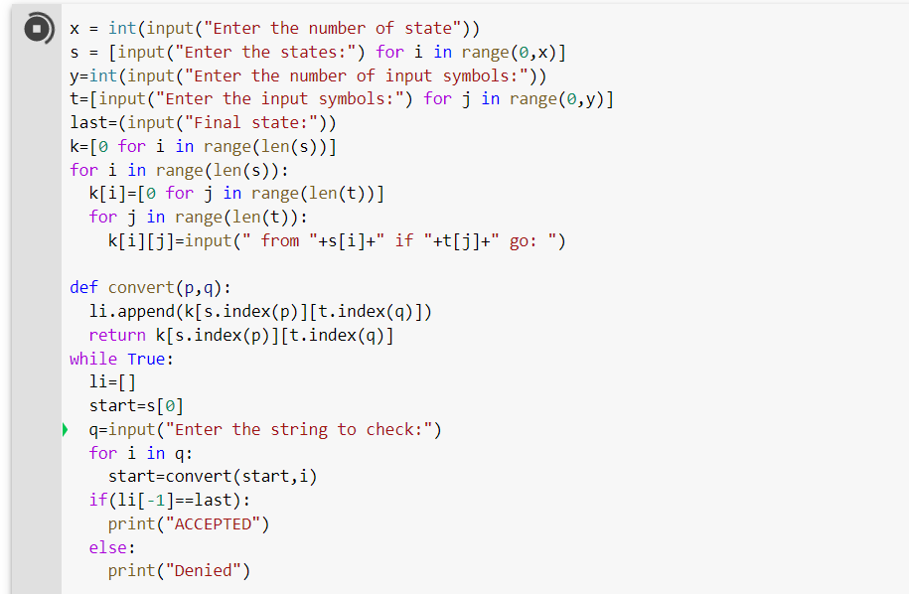

OUTPUT:

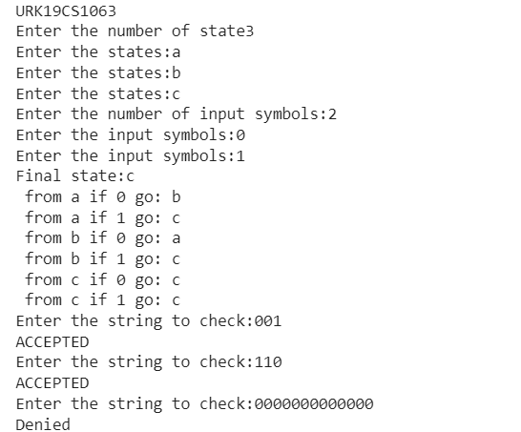

Link: https://colab.research.google.com/drive/1E30uMQwj2ZyFgakACOrrqeTqcPfxHusI#scrollTo=7PgVAxirJ-go&uniqifier=1

Result:
Thus the program was executed and verified successfully.

